

NIHVA Dock−Leveler
Operation & maintenance Manual

DOCK LEVELER – NDL-025,026

CLIENT: - Jolly Containers

DOCK LEVELER MANUAL

A DESPATCH & UNLOADING

- Loading, for dispatch, will be our responsibility. On receipt of the Dock-leveler at site, please check and ensure that there is no physical damage to the equipment.

- While unloading the equipment from the transporting vehicle, please ensure to use slings with rated capacity higher than the gross weight of the Stationary lift in packed condition.

- Slings MUST be hooked ONLY at specified positions. These positions are indicated and marked with a figure of ‘HOOK’. Improper sling position or improper slinging could cause damage to the equipment.

- ORDERING OF SPARES

- When ordering for spare, please specify the following in your Purchase Order.

  - Equipment Name

  - Model Number

  - Equipment Serial No.

  - Part name / Description

  - Part Number

  - Quantity required

  - Delivery period / time

  - Mode of dispatch

This would avoid ambiguity and help us serve you better.

DOCK LEVELER MANUAL

2

DATASHEET FOR DOCK LEVELER – NDL-025,026

CLIENT: - Jolly Containers
1.0 CONSTRUCTION DETAILS

1.1 |  | Required Capacity - each |  |  | : 09 ton
1.2 |  | Model No. |  |  | : NDL-025,026
1.3 |  | Leveler operation mode |  |  | : AC power pack hydraulically
operated
1.4 |  | Lip operation mode |  |  | :hydraulic
1.5 |  | Operation control |  |  | : by push buttons and control panel
1.6 Loading platform height from road
 |  |  | Level |  | : 1200 mm (Will be confirmed during
 |  |  |  |  | Detailing)
1.7 Travel above & below dock level |  |  |  |  | : (+) 350 / (-) 250 mm
1.8 Platform Size (w x l) |  |  |  |  | : 2030 x 2720 mm
1.9 |  | Lip size |  | (w x l) | : 2030 x 400 mm
1.10 Working length |  |  |  |  | : 3120 mm
1.11 Overall working size |  |  |  |  | : 2030x3120 mm
1.12 Maximum slope can be achieved |  |  |  |  | : 8 to 10%
1.13 Clear Pit dimensions (W x L x D) |  |  |  |  | : 2080x 2780 x 485 mm
1.14 Hydraulic power pack
1.14.1 |  |  | Make |  | “NIHVA”
1.14.2 |  |  | Driver type |  | : Direct by electric Motor
1.14.3 |  |  | Absorbed power |  | : 0.75 kW
 | 1.14.4 Motor Ratings |  |  |  | : 0.75/1 kW /HP
 | 1.14.5 Degree of protection for motor: IP 55
 | 1.14.6 Class of Insulation for motor |  |  |  | : Class F with temp. Rise limited to
 |  |  |  |  | Class B
 | 1.14.7 |  |  | Motor RPM | : 1410
 | 1.14.8 |  |  | Pump design flow | : 1.8 LPM
 | 1.14.9 |  |  | Pump pressure | : 200 (max) Kg/cm²g
 | 1.14.10 |  |  | Safety valve set pressure | : 90 Kg/cm²g
 | 1.14.11 in built safety valve |  |  |  | : Yes
 | 1.14.12 |  |  | Pump type | : Gear
 | 1.14.13 |  |  | Valves required | : By vendor
 | 1.14.14 Volume of oil receiver |  |  |  | : 5 Lit
- Dimensions of power pack
 | Unit | : 400 H x 560 L x 340 W mm
1.14.16 First fill of oil / Qty |  | : By Vendor
1.14.17 | Hydraulic tubing | : By Vendor
1.14.18 | Instrumentation | : By vendor
1.14.19 | Control panel | : By vendor

DOCK LEVELER MANUAL

3

DOCK LEVELLER

INTRODUCTION:-

The hydraulic Dock Leveler is the result of many years’ experience in materials handling engineering. “NIHVA ” offers the best possible factor of safety with simple, easy to use controls. The high quality of manufacture gives a robust construction and many years of useful life. Each lip and platform movement can be individually controlled (or corrected) by push button.

The dock leveler can be set at any position. During loading, the Dock Leveler is in floating mode i.e. it follows the up/down movements of the vehicle deck. Even with lopsided vehicles, the Dock leveler lip will remain in contact, and toe-traps are avoided by the tilt built into the Dock Leveler.

The whole platform is designed to flex laterally adequately to adapt to sideways tilted vehicles. The leveler always seals perfectly to the lorry bed.

PRINCIPLE:-

Dock Leveler is an adjustable platform used between the transport vehicle and dispatch area of the warehouse of factory for efficient and safe material transfer applications. It bridges the gap between the dispatch area and the transport vehicle and compensates for variations in the truck bed height.

DOCK LEVELER MANUAL

4

CONSTRUCTION:-

It basically consists of heavy duty fabricated Top Chequered platform and bottom angle channel construction frame. Both are joined by stainless steel machined pins. Lip is hinged to the top platform by means of stainless steel pins.

Top Platform is reinforced with I Beam welded below the platform to strengthen the platform. The cylinder is mounted at the best advantage point against the top platform and bottom frame. Compact power pack includes a single HP motor with overload protection. Hydraulic Pump is Dowty make. Hydraulic operations are by using solenoid control valve.

FEATURES:-

- Convenient location of all controls.
- Independent deck and lip operation.
- Controls for quicker cycling time.
- Smooth dependable hydraulics.
- Quite operation at the touch of the button.
- Lower operating cost and fewer maintenance requirements.
- Recommended for container & loading unloading applications.
- Maintenance Strut.
- Toe guards.
- Heavy thickness of the lip gives good life.
- Self standing structure transfers load to the base of the pit, independent of pit skirting civil work.
- Profiled hinges gives good welding strength.
- No cross support imparts good flexibility.

DOCK LEVELER MANUAL

5

PRE – OPERATING INSTRUCTIONS:-

- Ensure the dock platform is empty.

- Ensure the truck is parked properly.

- Ensure the chocks to the truck to arrest the movement while loading.

- Ensure proper functioning of the switches.

- Ensure the truck height is within the range.

- Ensure no joint leakage.

DOCK LEVELER MANUAL

6

DOCK LEVELER MANUAL
7

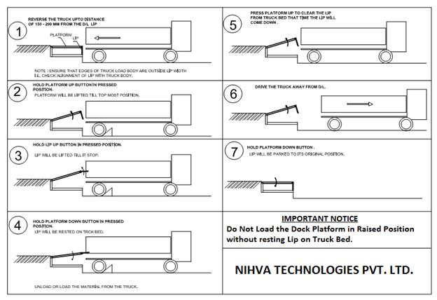

ROUTINE MAINTENANCE AND LUBRICATION

These recommendations are applicable to the Dock Leveler considering average daily usage of 15 to 20 times. If it is used more frequently, the same time intervals for the maintenance should be adjusted accordingly.

DAILY:-

- Check Hydraulic pipe lines for leak proof working.

- Check electrical connections for their proper working.

MONTHLY:-

- Grease the hinge pins at bottom frame and top plate joint and extension lip plate hinge joint.

- Grease the main Jack Cylinder and Lip Jack Cylinder joints.

DOCK LEVELER MANUAL

8

ASSEMBLIES

&

SPARE PARTS
LIST

DOCK LEVELER MANUAL

9

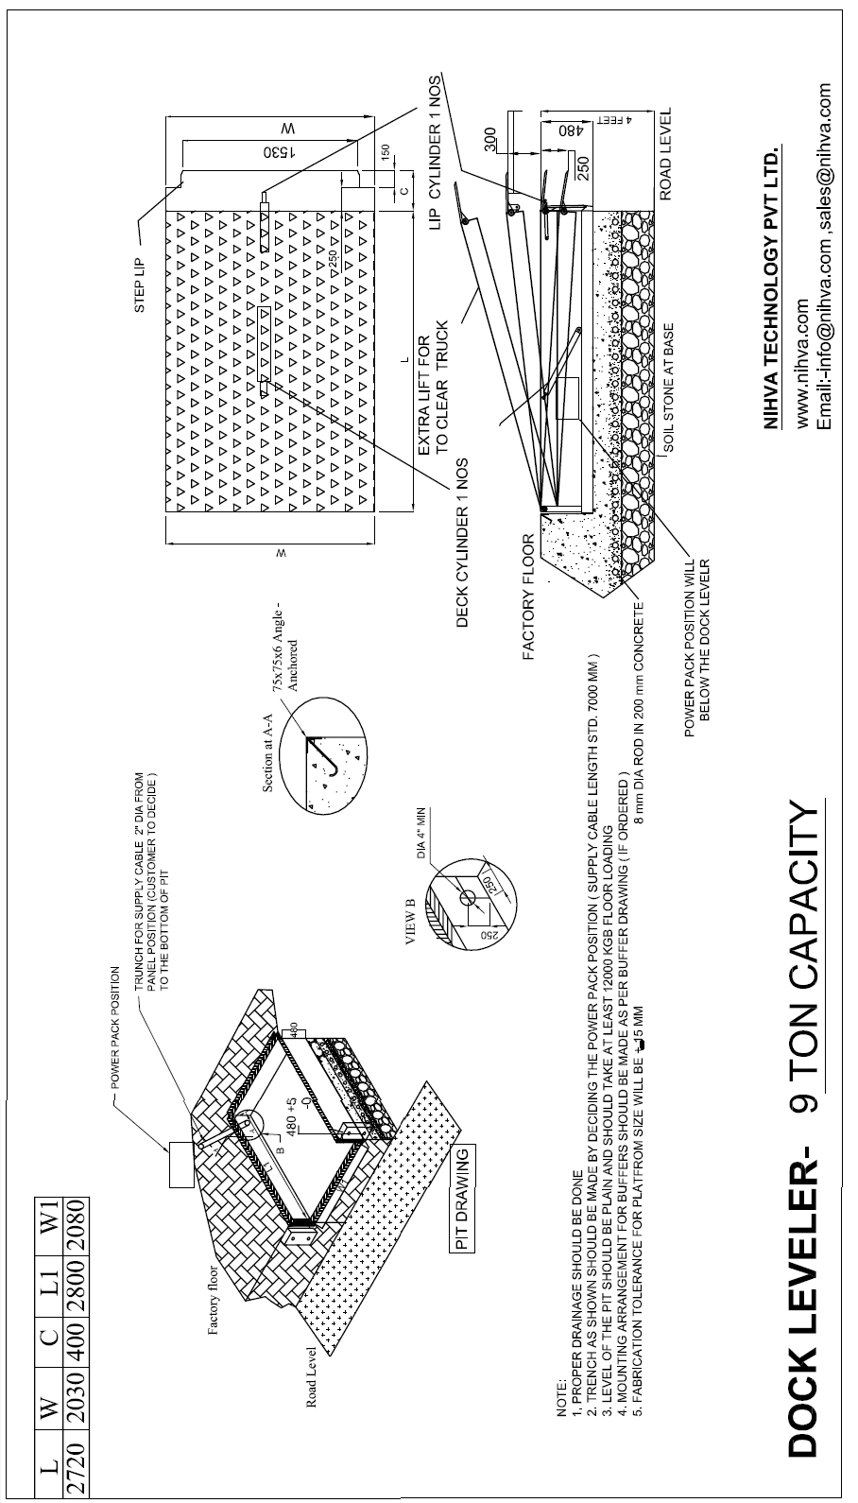

DOCK LEVELER MANUAL

10

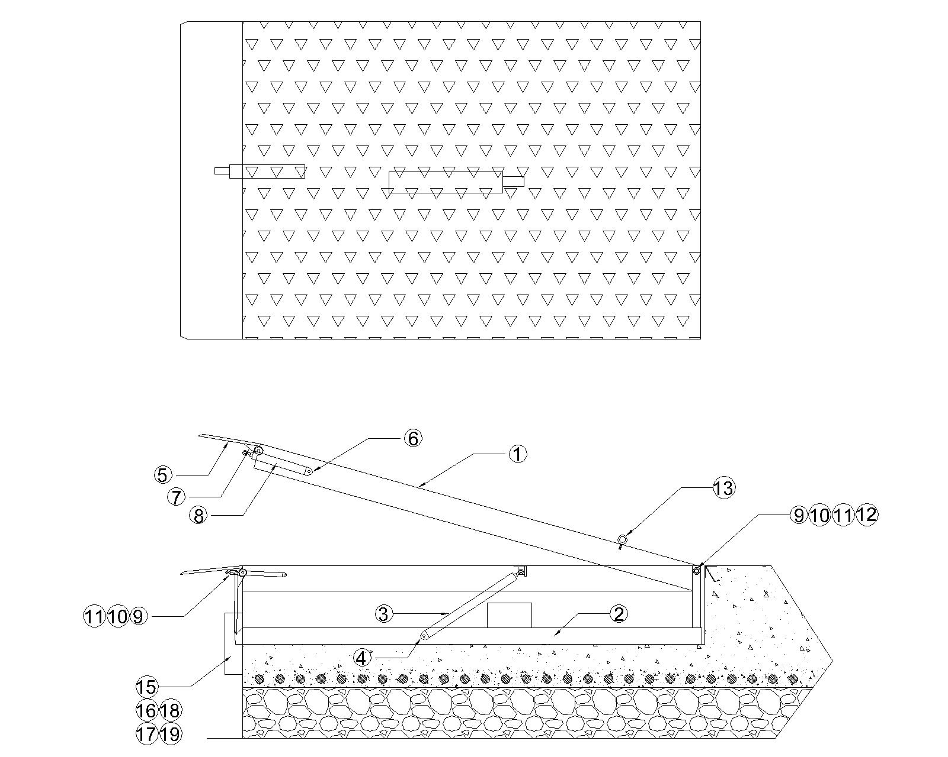

DOCK LEVELER MANUAL

11

SR. NO. | DESCRIPTION | QTY.
1 | TOP PLAT FORM WELDED ASSLY | 1
2 | BOTTOM FRAME WELDED ASSLY | 1
3 | MAIN JACK ASSLY | 2
4 | MAIN JACK PIVOT PIN | 4
5 | LIP PLATE | 1
6 | LIP JACK BOTTOM PIVOT PI N | 1
7 | LIP JACK TOP PIVOT PIN | 1
8 | LIP JACK ASSLY | 1
9 | PLATFORM & LIP PIVOT PIN | 2
10 | PIN LOCKING WASHER | 2
11 | M6 X 20 L CSK BOLT | 8
12 | GREASE NIPPLE | 6
13 | I BOLT M16 | 4
14 | ANCHOR FASTNER | 8
15 | RUBBER BUFFER | 2
16 | RUBBER BUFFER PIVOT PIN | 4
17 | SPLIT PIN | 8
18 | RUBBER BUFFER MTG. ANGLE | 4
19 | ANCHOR FASTNER | 8

DOCK LEVELER MANUAL

12

SPLIT LIP PLATE

PART NO-70000160

QTY-01
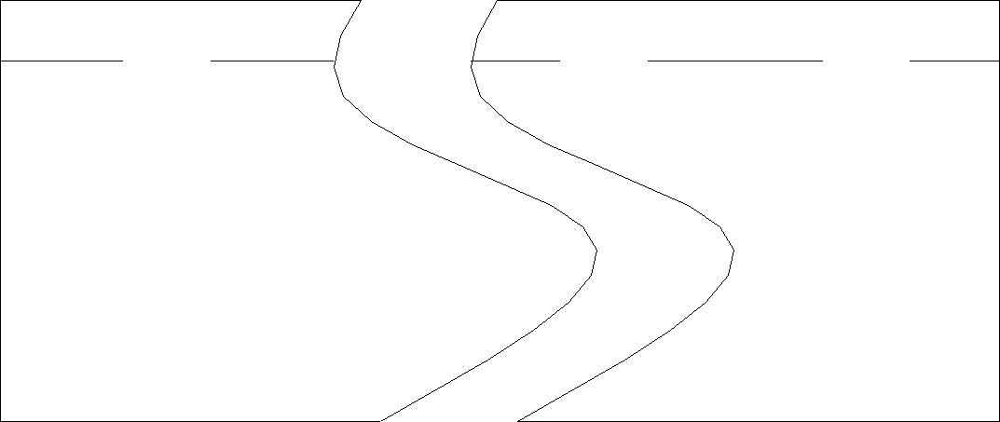

PLATFORM PIVOT PIN (REAR) PART NO-70000161
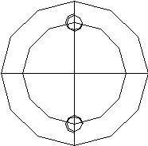
QTY-01
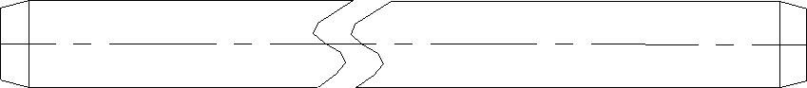

PIN LOCKING WASHER

PART NO-70000164

QTY-04

LIP JACK PIVOT PIN( TOP) PART NO-70000167 QTY-01

LIP JACK PIVOT PIN(BOTTOM ) PART NO-70000168

QTY-01

LIP PLATE PIVOT PIN (M.S)

PART NO-70000162

QTY-01
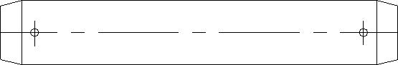

MAIN JACK PIVOT PIN( TOP) PART NO-70000165

QTY-01
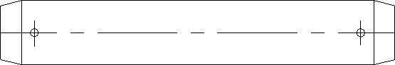

MAIN JACK PIVOT PIN(BOTTOM ) PART NO-70000166

QTY-01

DOCK LEVELER MANUAL

13

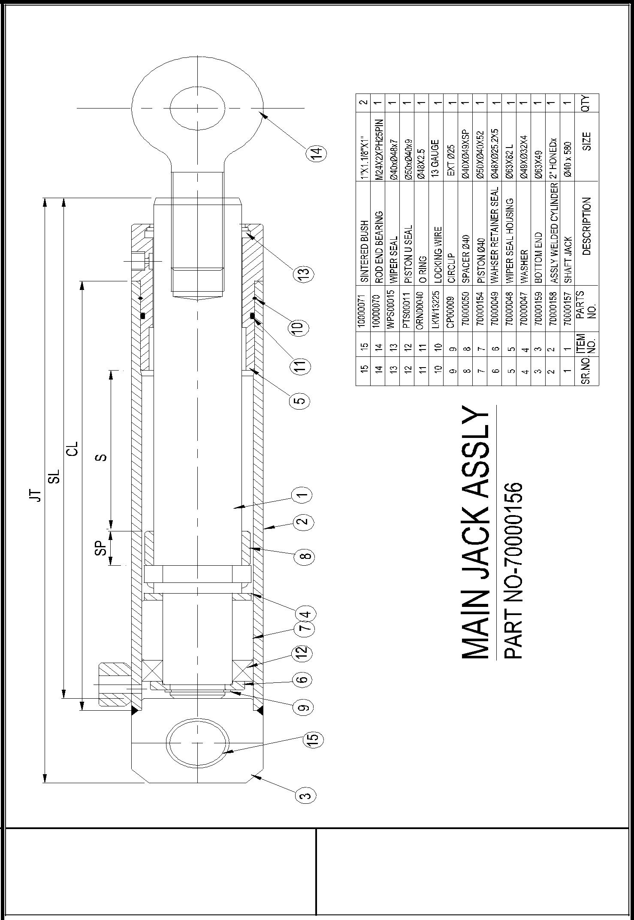

DOCK LEVELER MANUAL

14

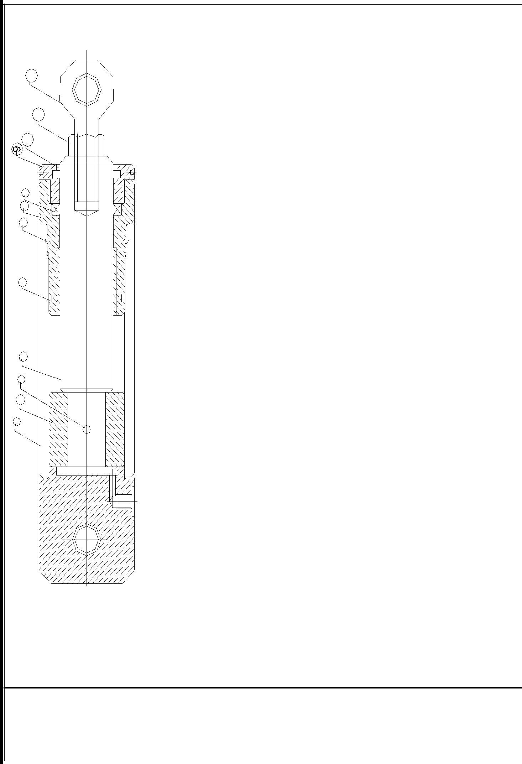

12

11

10

6 7 8

5

2 3 4

1

12 |  | REB00006 |  | ROD END BEARING | 1
11 |  |  |  | HEX NUT M-16X2P | 1
10 | WPS00002 |  |  | SEAL WIPER | 1
9 |  | 70000390 |  | WIPER SEAL HOUSING | 1
8 |  | RDS00003 |  | SEAL ROD | 1
7 |  | 70000389 |  | SEAL HOUSING | 1
6 | LKW13235 |  |  | WIRE LOCKING | 1
5 | ORN00002 |  |  | O RING | 1
4 | 70000388 |  |  | SHAFT(PLATED) | 1
3 | DSP00001 |  |  | SPRING PIN | 1
2 | 70000387 |  |  | PISTON | 1
1 | 70000386 |  |  | JACK CYLINDER | 1
SR.NO. |  | PARTS |  | DESCRIPTION | QTY
SR.NO. |  | NO. |  | DESCRIPTION | QTY

LIP JACK ASSLY

PART NO-70000383

DOCK LEVELER MANUAL

15

HYDRAULIC CIRCUIT

FOR DOCK LEVELER
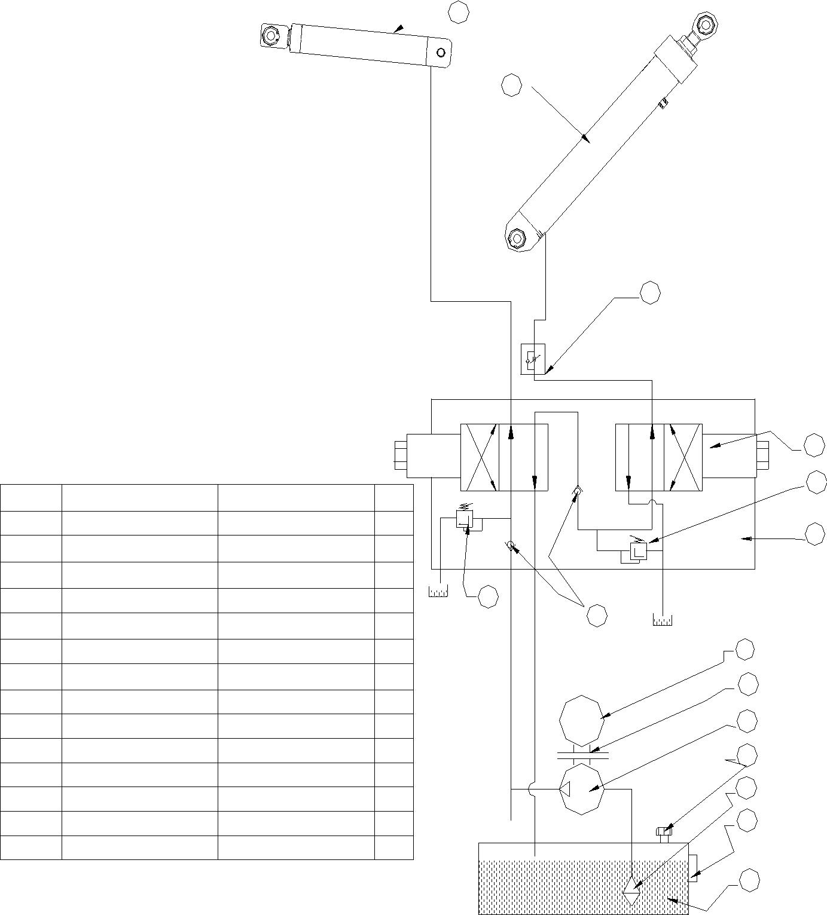

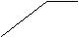10

9

7

 |  |  |  |  |  | A |  |  | B | A
 |  |  |  |  |  | B |  |  | B
 |  |  |  |  | SV2 |  |  |  |  |  | 1
 |  |  |  |  |  |  |  |  |  |  | SV1
SR.NO. | DESCRIPTION. |  | PART NO. | QTY. |  |  |  |  |  |  | 2
SR.NO. | DESCRIPTION. |  | PART NO. | QTY. | P |  | T | T |  |  | P
1 | SOLENOID VALVE (SV1,SV2) 10000232 |  |  | 2 |  |  |  |  |  |  | 12
 |  |  | 10000145 |  | RF1 |  |  | RF2
2 | RELIEF VALVE (RF1,RF2) |  | 10000145 | 2
3 | MOTOR 1HP,3PHASE |  | 10000228 | 1
4 | GEAR PUMP(OP-3006) |  | 10000016 | 1 | 2
4 | GEAR PUMP(OP-3006) |  | 10000016 | 1 |  |  |  | 13
5 | SUCTION STRANER |  | 10000229 | 1
6 | OIL LEVEL INDICATOR |  | 10000142 | 1 |  |  |  |  |  |  | 3
7 | THROTTLE VALVE |  | 10000025 | 1 |  |  |  |  |  |  | 8
8 | LOVEJOY COUPLING |  | 10000231 | 1 |  |  |  | M
9 | MAIN JACK ASSLY. |  | 70000156 | 1 |  |  |  |  |  |  | 4
10 | LIP JACK ASSLY. |  | 70000383 | 1 |  |  |  |  |  |  | 11
11 | BREATHER FSB-25 |  | 10000141 | 1 |  |  |  |  |  |  | 5
12 | MANIFOLD BLOCK |  | 70000385 | 1
13 | IN LINE CHECK VALVE | 1" | 10000230 | 2 |  |  |  |  |  |  | 6
 |  | 4
14 | OIL TANK 15LTR CAPACITY |  | 70000384 | 1
 |  |  |  |  |  |  |  |  |  |  | 14

DOCK LEVELER MANUAL

16

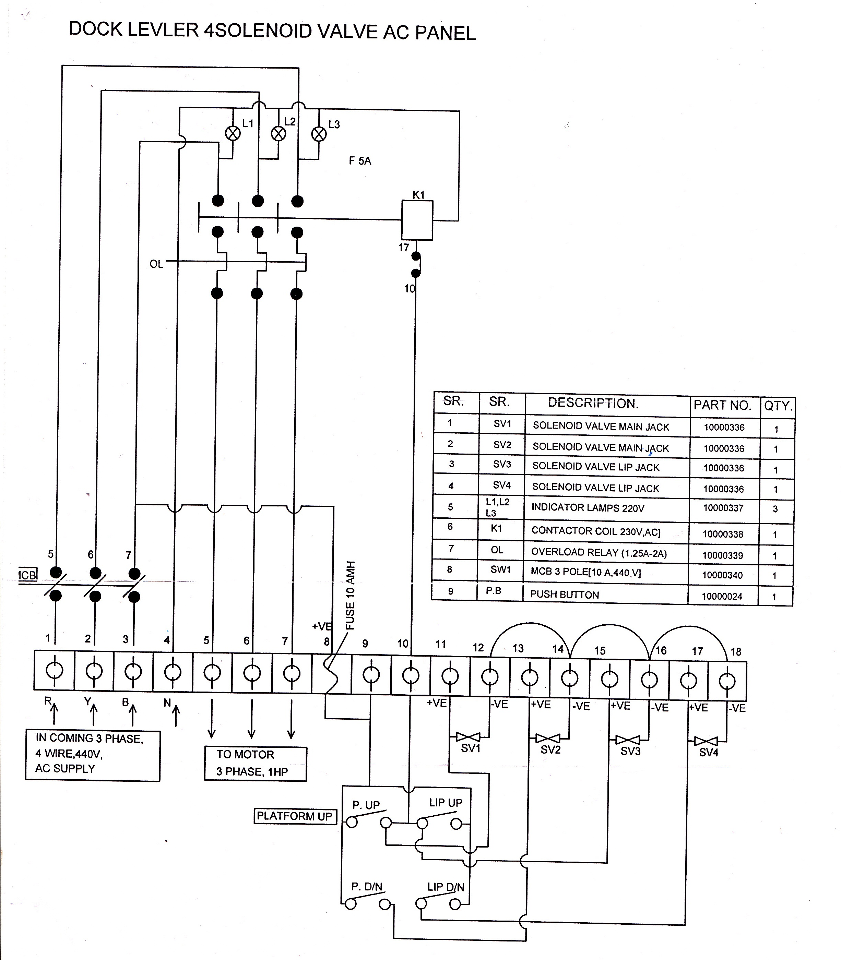

DOCK LEVELER MANUAL

17

